CORE JAVA INTERVIEW QUESTIONS

1Q) What is debugging?
a) Bug is also known as error.
The process of eliminating the bugs from the application is called debugging.

2Q) What is Java?
a) Java is a versatile programming language which is used to develop various applications like standalone, desktop application, distributed application, enterprise application, ERP application, Networking application and etc.

3Q) What is package?
a) A package is a collection of classes and interfaces.

4Q) Which package consider as default package in java?
a) java.lang package

5Q) Who is the creator of java?
a)James Gosling

6Q) In which year java was developed?
a) In 1995

7Q) Java originally known as ____ ?
a) OAK

8Q) How many memories are there in java?
a) There are five memories in java.
1) Method Area
2) Heap
3) Java Stack
4) PC Register
5) Native Method Stack
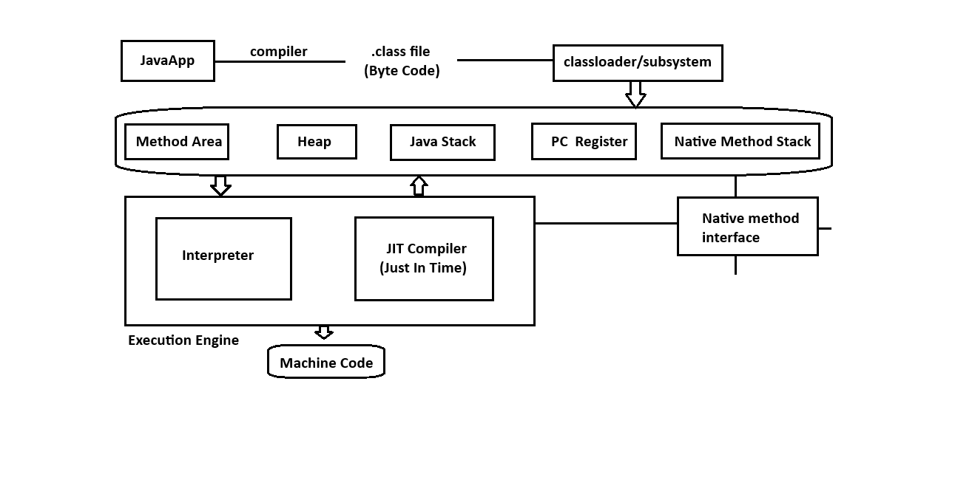9Q) What is JIT Compiler?
a)JIT compiler is a part of a JVM which is used to increase the execution speed of our program.

10Q) What is native method in java?
a) A method which is developed by using some other language is called native method.
To execute native methods we required a program called native method interface.
All native methods store in native method stack memory.

11Q) Is java platform dependent or independent?
a) Java is a platform independent at byte code level.Because java
Hence java is also known as WORA (Writen Once Run Anywhere).
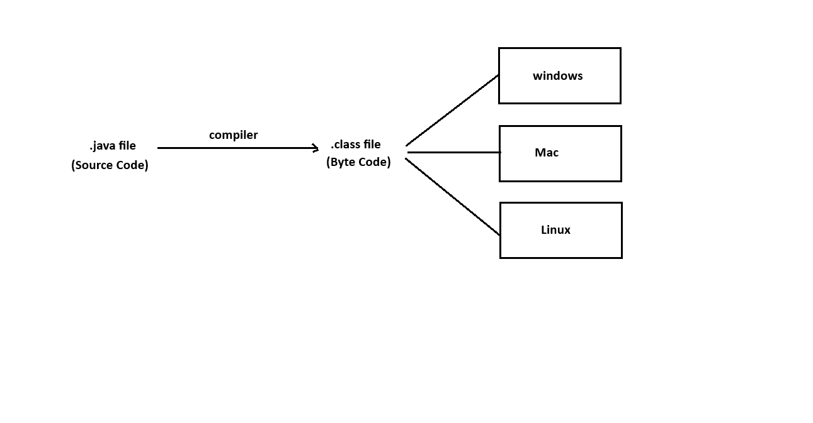12Q) Is JVM platform dependent or independent?
a) JVM is platform dependent

13Q) What is the difference between JDK, JRE and JVM ?
a) JDK:
JDK stands for “Java Development Kit”.
JDK is a installable software which consist Java Runtime Environment (JRE), Java Virtual Machine (JVM), Compiler (javac), Interpreter (java), an Archiever (.jar), document generator (javadoc) and other tools needed for java application development.

JRE : JRE stands for “Java Runtime Environment”.
JRE is a part of a JDK which provides very good environment to run java applications.

JVM : JVM stands for “Java Virtual Machine”.
JVM is a part of a JRE which is used to execute our program line by line procedure and It converts our byte code to machine code.
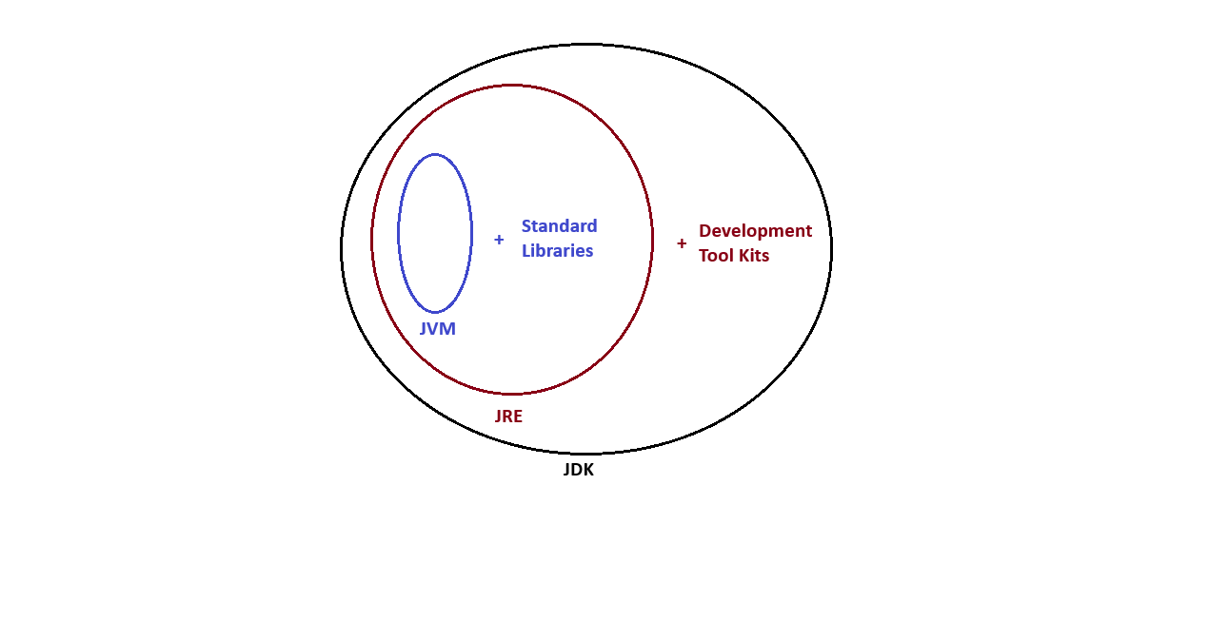14Q) Write a java program to display size of short datatype?
ex:-
class Test
{
public static void main(String[] args)
{
System.out.println(Short.BYTES); // 2
System.out.println(Short.SIZE); // 16
}
}

15Q) Write a java program to display size of int datatype?
class Test
{
public static void main(String[] args)
{
System.out.println(Integer.BYTES); // 4
System.out.println(Integer.SIZE); // 32 }
}

16Q) Write a java program to display size of long datatype?
class Test
{
public static void main(String[] args)
{
System.out.println(Long.BYTES); // 8
System.out.println(Long.SIZE); // 64
}
}

17Q) Jack and John both are best friends in a town. One day while going to school they saw one beggar. Both they decided to help that poor guy. So Jack denote 100 rupees of his school fee and John gave 50 rupees of his pocket money. Write a java program to find out total contribution they have done to help a needy person.
ex:-
class Test
{
//instance variables
int a=100,b=50;

public static void main(String[] args)
{
Test t = new Test();
t.sum();
}

//non-static method
public void sum()
{
System.out.println(a+b);
}
}

18Q) Is java purely object oriented or not?

No, java will not consider as purely object oriented programming language because java does not support many OOPS concepts
like multiple inheritance, operator overloading and more ever we depends upon primitive datatypes which are non-objects.

19Q) What is literal?

A value which is assigned to a variable is called literal.
A value which is not change during the program exection is called literal.
ex:
int i = 10;
| | |____ Value of a variable / Literal
| |_________ Variable name / Identifier
|______________ Datatype / Keyword

20Q)var keyword
============
A var keyword introduced in Java 10.

It enables local-variable type inference, allowing the compiler to automatically determine the variable's type based on the value assigned to it.

21Q) Explain important features in Java?

We have following important fetures in java.
1) Simple
2) Object oriented
3) Platform independent
4) Portable
5) Architecture Neutral
6) Robust
7) Multithreaded
8) High performanced
9) Highly secured
10) Distributed
and etc.

